**Dyanamic Table**

1. **Task Description**

To create a dynamic table in React, define a Table component that takes an array of objects as a prop. This component extracts keys from the first object to generate table headers and maps through the array to create rows. For instance, passing [{ name: 'Alice', age: 25 }, { name: 'Bob', age: 30 }] will automatically create a table with "Name" and "Age" as headers, adapting flexibly to any array input for displaying tabular data.

1. **Task Output Screenshot**

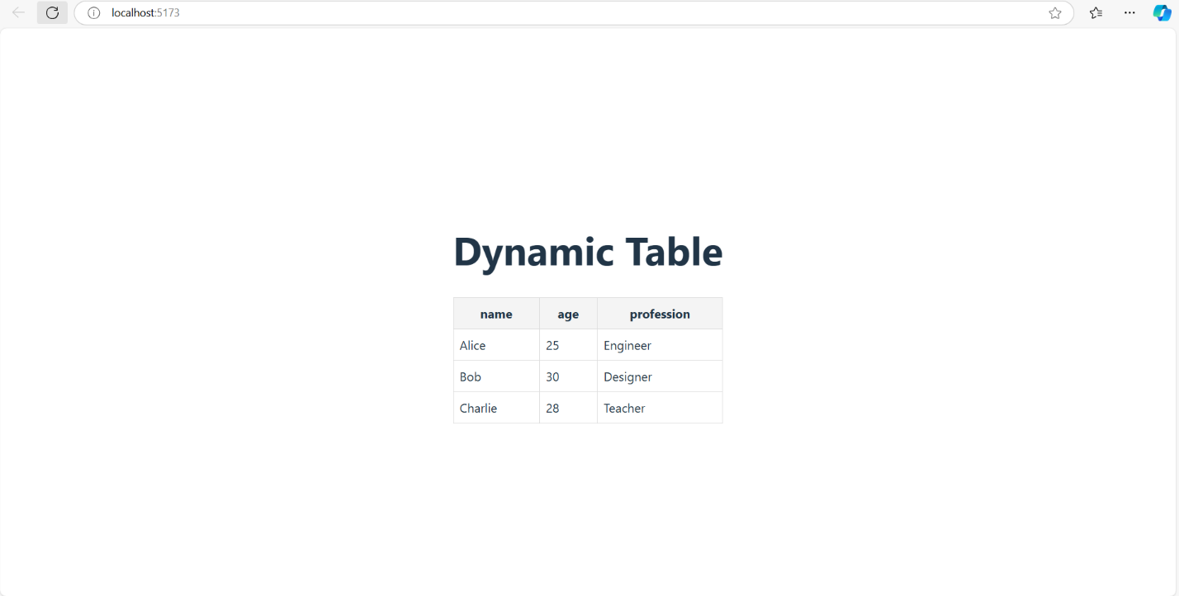

1. **Widget/Algorithm Used In Task**

• **Data Mapping**: Utilizes the map function to iterate through the array of objects, creating table rows dynamically.

• **Dynamic Header Creation**: Automatically generates table headers by extracting keys from the first object in the array.

• **Conditional Rendering**: Implements conditional rendering to display a message when no data is available.

• **Reusability**: Designed as a reusable component for easy integration across different parts of the application